Unsupervised Learning - Exercise 1
Naama Avni 208523456

Q1

Part A
The function q_1_a create the required clusters based on the mentioned parameters using the function generate_clusters_a.
The function description:
Creates M clusters of points based on Gaussian distribution.

Parameters:
- S (pd.Series): Series of size M with the number of points in each cluster.
- C (pd.DataFrame): DataFrame of size M x D representing the centers of the clusters.
- W (pd.Series): Series of size M with the width (standard deviation) of each cluster.

Returns:
- pd.DataFrame: DataFrame with D+1 columns, containing the coordinates of the points and the cluster number.

The code includes clear documentation and comments that explain the function's logic.

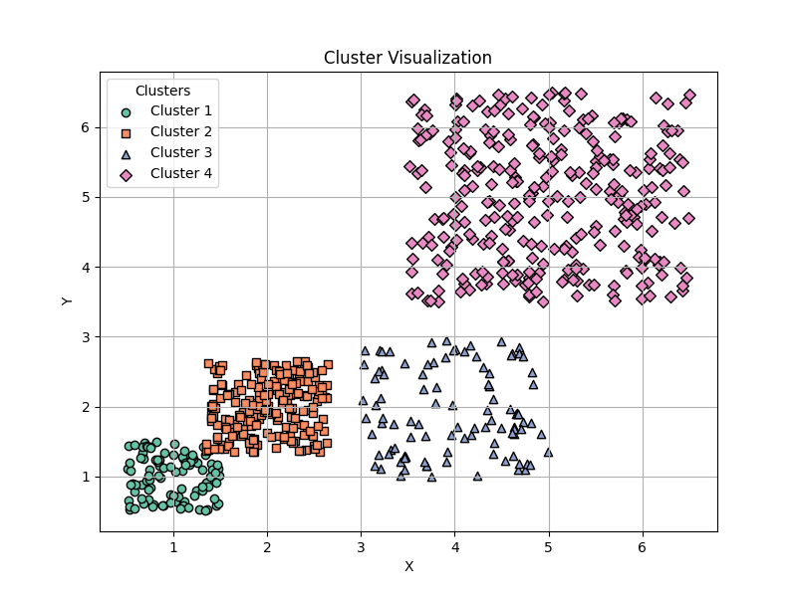
The required output:(also available in the question directory)

Part B
The function q_1_b create the required clusters based on the mentioned parameters using the function generate_clusters_b.
The function description:
Creates M clusters in Gaussian distribution with the given parameters.

Parameters:
- S (pd.Series): Series of size M with the number of points in each cluster.
- C (pd.DataFrame): DataFrame of size M x (D + D^2), where the first D columns represent the cluster centers
and the next D^2 columns represent the flattened covariance matrices.
- D (int): The number of dimensions for the clusters.

Returns:
- pd.DataFrame: DataFrame with D+1 columns (coordinates and cluster label).

The code includes clear documentation and comments that explain the function's logic.

The required output:(also available in the question directory)

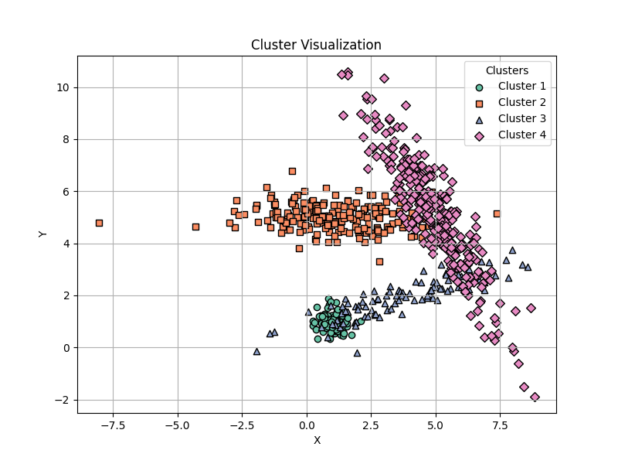

Part C
The function q_1_c create the required clusters based on the mentioned parameters using the function generate_clusters_c.
The function description:
Generate a Gaussian cluster and a ring cluster around it.

Parameters:
- center: Tuple (x, y), center of both clusters
- sigma: Standard deviation (not variance) of the Gaussian cluster
- Ng: Number of points in the Gaussian cluster
- inner_radius: Inner radius of the ring cluster
- ring_width: Width of the ring
- Nr: Number of points in the ring cluster

Returns:
- A (Ng + Nr, 3) numpy array: [x, y, label]

The code includes clear documentation and comments that explain the function's logic.

The required output:(also available in the question directory)

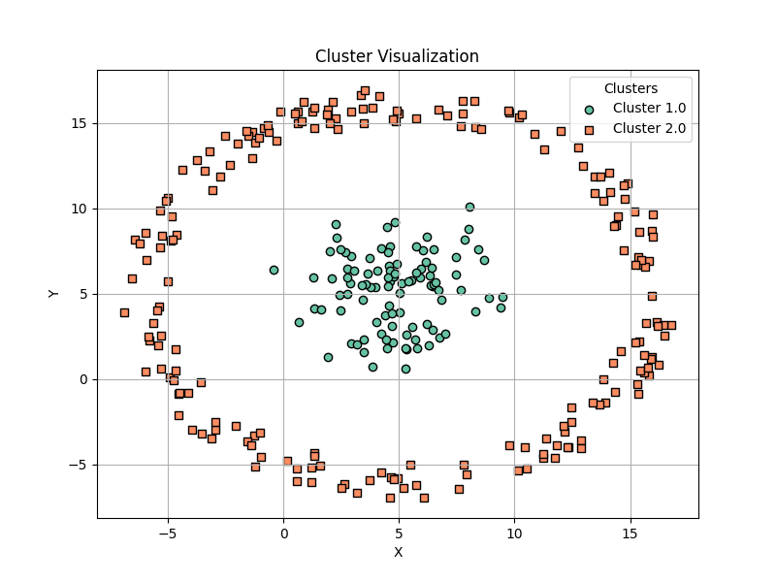

Q2
The required logic implemented in the function inner_cluster_similarity
What the function does:
This function calculates how tight or compact each cluster is by measuring how close the points are to each other inside each cluster.

Step-by-step explanation:
- Input:
  - A dataset with 2D points (as a pandas DataFrame), and
  - The cluster labels (which point belongs to which group).
- For each cluster (based on the labels you gave):
  - It looks at all the points in that cluster,
  - Then, it calculates the distance between every possible pair of points in that cluster,
  - And it adds up all those distances.
- Finally, it adds up the distances from all clusters, and returns that total.
- Output:
  - A single number that tells you how "spread out" your clusters are in total.
A lower number means the clusters are tighter and more compact (which is usually better).

Q3
This script runs K-Means clustering on three different datasets using three initialization strategies:
- Random initialization
- Farthest-point initialization
- Initialization based on DBSCAN
Then, for each result:
- It calculates how tight the clusters are (using inner-cluster similarity),
- It plots the clusters, and
- It shows how clustering quality changes as the number of clusters k increases.

k_means() Function
This function does the actual K-Means clustering:
- It can start with random centers, farthest points, or cluster centers estimated by DBSCAN.
- It loops, assigning points to the closest center and updating those centers, until it either converges or hits the iteration limit.
- It returns the cluster labels (which cluster each point belongs to).

plot_similarities_scores() Function
- This takes a list of similarity scores (how tightly packed each cluster is) for each k.
- It prints them and plots a line graph of similarity vs number of clusters (k).

main Block
This part runs the full clustering analysis when the script is executed:
For each dataset:
- It runs K-Means 7 times, with k=1 to 7, using:
  - Random initialization
  - Farthest-point initialization
- For each run:
  - It clusters the data.
  - Plots the results.
  - Calculates and stores the inner-cluster similarity (a score showing how compact the clusters are).
- Then it plots how similarity changes with k (for both init strategies).
- After that, it runs K-Means initialized by DBSCAN (which auto-detects k) and plots the result.

The text output available in the appendix, and all plots available in the question directory.

Q4

PAM Function
This implements PAM (Partitioning Around Medoids):
- It randomly picks k medoids (representative data points).
- Then, it assigns each data point to the nearest medoid.
- After that, for each cluster, it tries to find a better medoid (the most central point in the cluster).
- It keeps updating medoids until they stop changing.
- Returns: the medoids and the cluster assignments (labels).

CLARA Support Function: pam_on_subset
This runs PAM on a small sample of the full data (used inside CLARA). Once it finds medoids on the sample, it:
- Assigns all points in the full dataset to the closest medoid.
- Calculates the total cost (how far points are from their medoids).

CLARA Function
This implements CLARA (Clustering Large Applications):
- It runs pam_on_subset multiple times (on different random samples).
- It keeps track of the best result (lowest cost).
- Finally, it returns the medoids and labels from the best sample.

Main Script

1. Load 3 datasets from Q1:
They’re likely different cluster structures to test on.

2. Run PAM:
- For each dataset:
  - Try k = 1 to 7 clusters
  - Run PAM
  - Measure how tightly packed the clusters are (inner-cluster similarity)
  - Plot the clusters
  - Plot how similarity changes as k increases
- Also, measure total execution time for PAM.

3. Run CLARA:
- Same process as PAM, but using the CLARA method (more scalable)
- Again, measure similarity and runtime

4. Compare Runtime:
Print how long PAM and CLARA took so you can compare speed.
The text output available in the appendix, and all plots available in the question directory.

Appendix:

Q3 text output:
Running K-means clustering on datasets:
Running K-means with k=1 on dataset 1 on random initialization
Running K-means with k=1 on dataset 1 on farthest initialization
Running K-means with k=2 on dataset 1 on random initialization
Running K-means with k=2 on dataset 1 on farthest initialization
Running K-means with k=3 on dataset 1 on random initialization
Running K-means with k=3 on dataset 1 on farthest initialization
Running K-means with k=4 on dataset 1 on random initialization
Running K-means with k=4 on dataset 1 on farthest initialization
Running K-means with k=5 on dataset 1 on random initialization
Running K-means with k=5 on dataset 1 on farthest initialization
Running K-means with k=6 on dataset 1 on random initialization
Running K-means with k=6 on dataset 1 on farthest initialization
Running K-means with k=7 on dataset 1 on random initialization
Running K-means with k=7 on dataset 1 on farthest initialization

Similarity scores:, dataset 1, K-Means Random Initialization
k=1: similarity = 721185.6546
k=2: similarity = 189135.5070
k=3: similarity = 116775.6080
k=4: similarity = 86600.9415
k=5: similarity = 46892.0848
k=6: similarity = 39497.4418
k=7: similarity = 36033.5754

Similarity scores:, dataset 1, K-Means Farthest Initialization
k=1: similarity = 721185.6546
k=2: similarity = 189135.5070
k=3: similarity = 116775.6080
k=4: similarity = 77081.1478
k=5: similarity = 64878.0908
k=6: similarity = 34703.4243
k=7: similarity = 30794.6381

Running K-means with DBSCAN initialization on dataset 1

Running K-means with k=1 on dataset 2 on random initialization
Running K-means with k=1 on dataset 2 on farthest initialization
Running K-means with k=2 on dataset 2 on random initialization
Running K-means with k=2 on dataset 2 on farthest initialization
Running K-means with k=3 on dataset 2 on random initialization
Running K-means with k=3 on dataset 2 on farthest initialization
Running K-means with k=4 on dataset 2 on random initialization
Running K-means with k=4 on dataset 2 on farthest initialization
Running K-means with k=5 on dataset 2 on random initialization
Running K-means with k=5 on dataset 2 on farthest initialization
Running K-means with k=6 on dataset 2 on random initialization
Running K-means with k=6 on dataset 2 on farthest initialization
Running K-means with k=7 on dataset 2 on random initialization
Running K-means with k=7 on dataset 2 on farthest initialization

Similarity scores:, dataset 2, K-Means Random Initialization
k=1: similarity = 1035579.5350
k=2: similarity = 381920.3211
k=3: similarity = 218408.4098
k=4: similarity = 113221.7302
k=5: similarity = 78842.6497
k=6: similarity = 59961.4275
k=7: similarity = 53400.1135

Similarity scores:, dataset 2, K-Means Farthest Initialization
k=1: similarity = 1035579.5350
k=2: similarity = 381920.3211
k=3: similarity = 198189.2247
k=4: similarity = 113105.3801
k=5: similarity = 78987.8955
k=6: similarity = 66451.2130
k=7: similarity = 48934.3383

Running K-means with DBSCAN initialization on dataset 2

Running K-means with k=1 on dataset 3 on random initialization
Running K-means with k=1 on dataset 3 on farthest initialization
Running K-means with k=2 on dataset 3 on random initialization
Running K-means with k=2 on dataset 3 on farthest initialization
Running K-means with k=3 on dataset 3 on random initialization
Running K-means with k=3 on dataset 3 on farthest initialization
Running K-means with k=4 on dataset 3 on random initialization
Running K-means with k=4 on dataset 3 on farthest initialization
Running K-means with k=5 on dataset 3 on random initialization
Running K-means with k=5 on dataset 3 on farthest initialization
Running K-means with k=6 on dataset 3 on random initialization
Running K-means with k=6 on dataset 3 on farthest initialization
Running K-means with k=7 on dataset 3 on random initialization
Running K-means with k=7 on dataset 3 on farthest initialization

Similarity scores:, dataset 3, K-Means Random Initialization
k=1: similarity = 521434.6253
k=2: similarity = 221197.0661
k=3: similarity = 118762.6807
k=4: similarity = 81545.6783
k=5: similarity = 43346.6120
k=6: similarity = 34532.2046
k=7: similarity = 30022.8133

Similarity scores:, dataset 3, K-Means Farthest Initialization
k=1: similarity = 521434.6253
k=2: similarity = 212046.7813
k=3: similarity = 118551.4926
k=4: similarity = 76837.3451
k=5: similarity = 43092.1169
k=6: similarity = 33563.6705
k=7: similarity = 29399.4981

Running K-means with DBSCAN initialization on dataset 3

Q4 text output:

Running PAM with k=1 on dataset 1
Running PAM with k=2 on dataset 1
Running PAM with k=3 on dataset 1
Running PAM with k=4 on dataset 1
Running PAM with k=5 on dataset 1
Running PAM with k=6 on dataset 1
Running PAM with k=7 on dataset 1

Similarity scores:
k=1: similarity = 731943.2026
k=2: similarity = 195106.1767
k=3: similarity = 120087.9554
k=4: similarity = 89461.0936
k=5: similarity = 48168.3289
k=6: similarity = 42226.3253
k=7: similarity = 37129.1750
Running PAM with k=1 on dataset 2
Running PAM with k=2 on dataset 2
Running PAM with k=3 on dataset 2
Running PAM with k=4 on dataset 2
Running PAM with k=5 on dataset 2
Running PAM with k=6 on dataset 2
Running PAM with k=7 on dataset 2

Similarity scores:
k=1: similarity = 1017308.7599
k=2: similarity = 373919.3937
k=3: similarity = 203557.5116
k=4: similarity = 166211.1378
k=5: similarity = 81255.8152
k=6: similarity = 60539.8269
k=7: similarity = 47412.6549
Running PAM with k=1 on dataset 3
Running PAM with k=2 on dataset 3
Running PAM with k=3 on dataset 3
Running PAM with k=4 on dataset 3
Running PAM with k=5 on dataset 3
Running PAM with k=6 on dataset 3
Running PAM with k=7 on dataset 3

Similarity scores:
k=1: similarity = 519762.3578
k=2: similarity = 257384.7126
k=3: similarity = 135736.5703
k=4: similarity = 71605.9053
k=5: similarity = 42228.2342
k=6: similarity = 33280.2697
k=7: similarity = 29258.1144
Running CLARA with k=1 on dataset 1
Running CLARA with k=2 on dataset 1
Running CLARA with k=3 on dataset 1
Running CLARA with k=4 on dataset 1
Running CLARA with k=5 on dataset 1
Running CLARA with k=6 on dataset 1
Running CLARA with k=7 on dataset 1

Similarity scores:
k=1: similarity = 731943.2026
k=2: similarity = 195447.0053
k=3: similarity = 118504.7472
k=4: similarity = 93587.9922
k=5: similarity = 51159.7702
k=6: similarity = 59778.3495
k=7: similarity = 31465.6946
Running CLARA with k=1 on dataset 2
Running CLARA with k=2 on dataset 2
Running CLARA with k=3 on dataset 2
Running CLARA with k=4 on dataset 2
Running CLARA with k=5 on dataset 2
Running CLARA with k=6 on dataset 2
Running CLARA with k=7 on dataset 2

Similarity scores:
k=1: similarity = 1017308.7599
k=2: similarity = 436305.4798
k=3: similarity = 236751.0609
k=4: similarity = 113937.5717
k=5: similarity = 88459.1417
k=6: similarity = 69773.7235
k=7: similarity = 51433.7902
Running CLARA with k=1 on dataset 3
Running CLARA with k=2 on dataset 3
Running CLARA with k=3 on dataset 3
Running CLARA with k=4 on dataset 3
Running CLARA with k=5 on dataset 3
Running CLARA with k=6 on dataset 3
Running CLARA with k=7 on dataset 3

Similarity scores:
k=1: similarity = 519762.3578
k=2: similarity = 268119.2827
k=3: similarity = 161653.5703
k=4: similarity = 72158.3275
k=5: similarity = 43972.0287
k=6: similarity = 35684.6053
k=7: similarity = 26426.0821
PAM runtime: 18.5664 seconds
CLARA runtime: 12.5892 seconds

